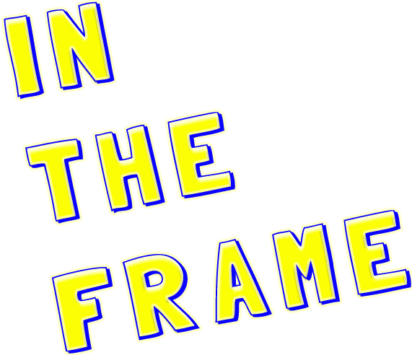 Application Form

Name:

Address:

Phone:

Email:

Why would you like to be part of ‘InThe Frame’?

What is your favorite kind of film?

Where and when would you prefer ‘In The Frame”?
- CDI Blackbird Leys - Tuesdays 11.00am – 5.00pm. (11 Feb – 15 April)
- Film Oxford - Thursdays 10.00am – 4.00pm. (13 Feb – 17 April)

Either print this form and post it to: In The Frame
Film Oxford
54 Catherine Street
Oxford
OX4 3AH
Or Email it to: geron@filmoxford.org

Deadline Thursday 30th January

